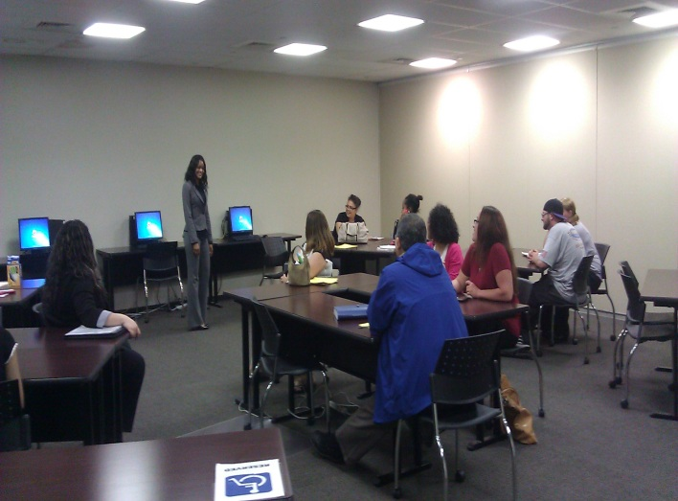

Johna Reiss is an Employment Counselor that has less than one year experience at Workforce Solutions. However, she has quickly become an emerging leader at Pasadena. Johna is very compassionate, friendly, professional, courteous, and studious. We often hear praises from her customers about the high level of customer service received by Johna, but also the many things they have learned and walked out with.
Johna facilitates our Networking clubs (Job Club). Nearly every week, we hear success stories of job seekers finding employment – thanks to tips received by Johna, or things she has identified as challenges that we may remove to quickly secure employment. Since we started our Network Clubs, nearly 30 people have reported new employment – most of them after learning something during one of these events. She instills confidence in everybody – customers and peers.
Johna is always smiling, and it’s contagious! She never shies away from helping her peers. She is always responsive to her customers, her peers, and management. She proposes new ideas, like ways to collaborate with business and community partners to increase employment opportunities; she proposed a new way to service senior citizens that lack computers skills by using youth that have computer skills but lack work experience as a way to help both achieve their goals; this idea is currently being considered as a way to improve our services.
Johna is a sponge. She is learning her job, but also every single position within the career office because she wants to be the most resourceful and knowledgeable staff member to better serve her customers. She gets the big picture but also pays attention to the small details.
Johna exemplifies the Guiding Principles. She thinks outside the box and goes the extra mile; she advocates for her customers.

