Upgraded Office 365

Office 365 Frequently Asked Questions

​​ What is Of​fice ​365?
​Microsoft Office 365 is a cloud​-based suite of solutions that includes Office desktop applications and Exchange Online (cloud-based email and calendar application) as well as other collaborative office applications. ​

​​ Which Office applications do I receive?
The Office suite includes Word, Excel, PowerPoint, Outlook, OneNote, Publisher and Access.​

​​ Can I install Office Suite on my personally-owned computer?
​Yes. Workforce Solution employees can download and install Microsoft suite on their personally-owned computer through Workforce Solutions’ Office 365 license. You can install Office suite on up to 5 personal and work devices (Windows, iOS, and Android).

​​ What features are available in new Exchange Online?
You have all the same features you do today with Workforce Solutions’ owned Exchange email server plus some new features and enhancement.

• ​Larger mailbox size (50GB).
• Built-in Anti-SPAM Filter

New security features: ​

• Information Rights Management - you can assign permission to an email message to help prevent sensitive information from being printed, forwarded, or copied or accessed by unauthorized people.
• Email Encryption – There is now a standard method to send an encrypted email. You can encrypt an email message to protect sensitive information and ensuring only the intended recipients can view your messages.

​​ Where is my Barracuda spam quarantine report?
With Office 365 and Exchange online, Barracuda will no longer be providing spam filtering services and thus you will no longer get a spam quarantine report. ​​

​​So what is filtering out the spam messages and how do I check to see if someone was blocked?
Office 365 and Exchange online now provides spam and malware filtering for all emails incoming and outgoing from Workforce Solutions. Any emails that are marked as Spam will now be located in your Outlook’s Junk folder. You can check there to see if any of your incoming email was marked as spam.​

​​ What if I do not find what I am expecting in my Junk folder?
Similarly, with the Barracuda system, you should contact Workforcesecurity@wrksolutions.com if you did not find what you were looking for. We will assist you in determining why you did not receive the email.​​​

​​ How can I block a sender or add a sender to my safe sender list?
You can setup your personal Junk Email filters.

​​My Office applications is asking me to login. I enter my username and password but it is not accepting it. Why is that?
Office 365 requires our login to be formatted in a different manner. The correct format is as follows: yourusername@wrksolutions.com​​

​​ What is the new address for Workforce Solutions webmail?
The new address is http://outlook.office365.com. ​​

How to Encrypt an Email Message

​​​Office 365 has email encryption built into the system. If you need to send an email that contains sensitive information, you are able to encrypt the message so that only the intended recipient can decode and consume the information.
See the following steps on how to encrypt an email, how it gets delivered, and how the recipient will retrieve and decrypt the message:
- Encrypt an email
Insert the text [SecureMessage] anywhere in the subject line of your message.
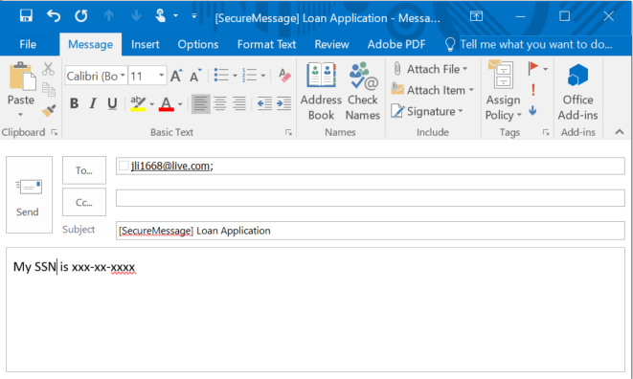
You can also create a "Quick Step" to automatically open an email with [SecureMessage] already in the subject line. To do this
  - ​Open Outlook
  - On the Home tab, click “Create New” above “Quick Steps”
  - Enter “Encrypt” as the Name
  - Click the drop down arrow next to “Choose an Action” and select “New Message”
  - Click “Show Options”
  - Enter [SecureMessage] as the Subject
  - Click “Finish”
“Encrypt” will now show up as a Quick Step.

- Delivery of an encrypted email:
A message that is encrypted by Office 365 is delivered to a recipient's inbox just like any other email message, but it contains an HTML file attachment. See example below.
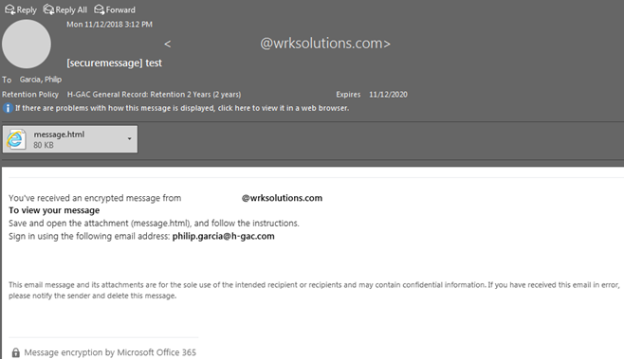
When the recipient clicks on the attached file, it will direct them to Office 365 Message Encryption portal containing instructions on how to view the message. The recipient will need to make a determination on what is the best method to view the message. Once the recipient successfully authenticates, they will see the message. See example below.

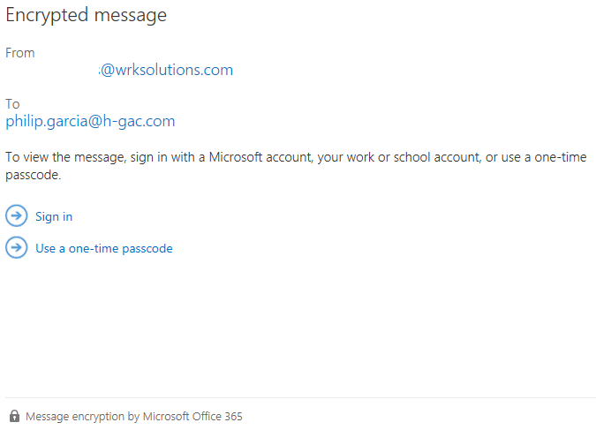

Microsoft OneDrive for Business Basics

​​ Introduction
OneDrive for Business is a personal online storage space hosted at Microsoft data centers that is included in your Office 365 subscription provided for you by Workforce Solutions. You can use it to store work files with ease and security, access your work files remotely, share your files with business colleagues as needed, and even edit Office documents together in real time with Office Online. The OneDrive for Business service is not the same as the OneDrive service offered by Microsoft to individuals. For information on the differences, see How does OneDrive for Business differ from OneDrive? Microsoft’s website.

Benefits of OneDrive for Business
Workforce Solution's OneDrive implementation offers the following capabilities:
Store and share files
- Store up to 50 GB of data in the cloud.
- 10 GB maximum file size.
- Share files with other Workforce Solution Office 365 users.
Access and synchronize files easily
- Access files directly from Microsoft Office desktop applications.
- Synchronize local files on authorized Workforce Solution computers with files in OneDrive.​

Usage Instructions
How to Access OneDrive for Business
- Login to the Office 365 portal page (http://login.microsoftonline.com) with your username and password.
- Click on the OneDrive icon at the top of the page.
- In addition to the web interface, there are specific folders on your workstation that will be synchronized with OneDrive. All your files will be accessible from here directly. For more information on folder synchronization, please see the Folder Synchronization section below.
IMPORTANT NOTE: The first time you access OneDrive for Business, you may get a message that says your OneDrive is almost ready. This message simply indicates that although your account has been enabled, it has not yet been activated. This message usually disappears within a day, but could take longer.​

Data Responsibility and Recovery
Employees are responsible for adhering to retention policies and managing their data responsibly:
- To protect the agency from data spillage, only share with specific individuals, and never with "everyone" or "public".
- Use caution when sending links to shared folders. Like email attachments, links can be forwarded with the consequence that information can be shared to unintended recipients.
- OneDrive for Business is not intended to be used as a permanent storage.
All files saved to OneDrive will be treated in a similar manner to files saved to a local computer. There will not be any backups performed by Data Services on these files. The ability to recover lost files will be solely based on the technology it is stored on. For information on recovery capabilities of OneDrive, please see Delete or restore files and folders in OneDrive Microsoft Website.​​

