Workforce Solutions

Financial Aid Eligibility

Child Care Development Fund

Parent Share of Cost

There are a number of parts to determining Parent Share of Cost. This Guide will present these parts and guide staff to correctly determining the Parent Share of Cost.

**TWIST System Calculations.** TWIST will automatically determine a Parent Share of Cost using a sliding scale derived from the Gross Monthly Income and the number of children in care. In TWIST, these are called the System Calculations.

View the Share of Cost sliding scale in TWIST under the Child Care Administration menu of the WDA Administration section of TWIST. Locate the Parent Share of Cost amounts for a customer by finding the customer’s household (HH) size and income range in the chart. At the top of the column is the share of cost amounts for the first child and additional child(ren). These are the amounts TWIST uses in the System Calculations.

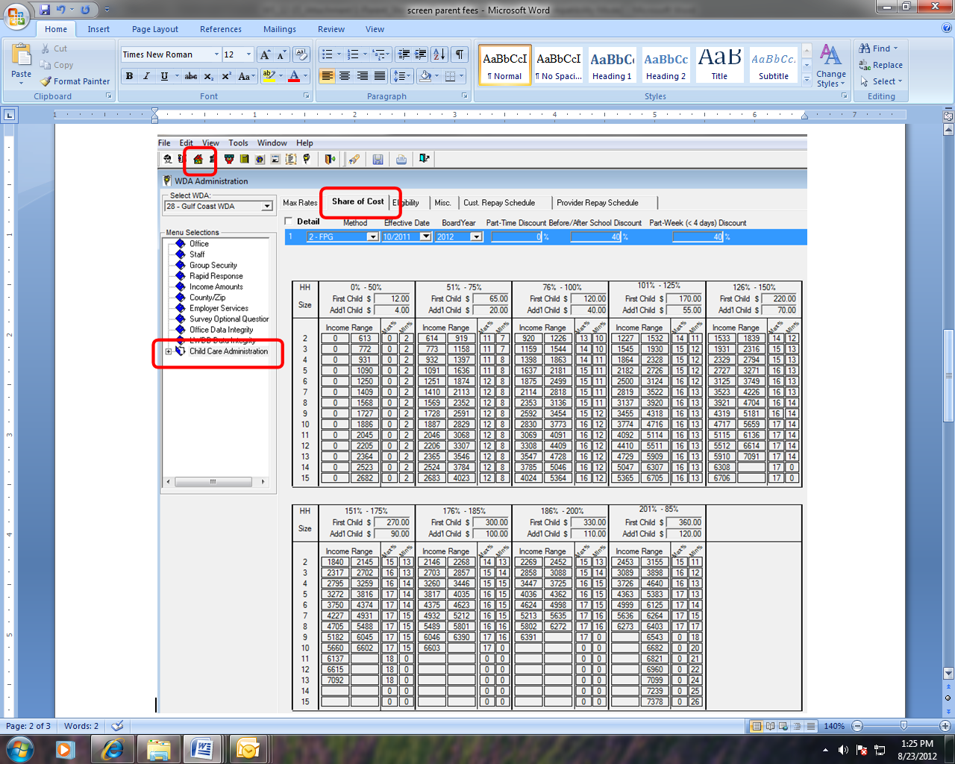

The System Calculations also attach the Parent Share of Cost to the provider.

When you select Copy System Calculations, TWIST will copy the System values into the Authorized values.

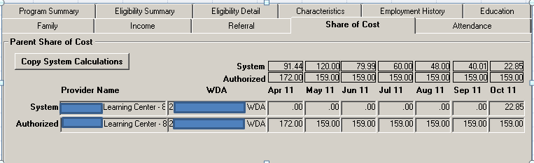

**Discounts.** Workforce Solutions authorizes a discount to the Parent Share of Cost for this reason:

* New customers and Choices and SNAP customers who transition to employment upon the parent’s selection of and acceptance and continued care by a Texas Rising Star (TRS)-certified provider. Staff must manually apply this discount.
  + Staff will use the Discount to Parent Share of Cost Worksheet to determine the discounted Parent Share of Cost. Staff will record the **Adjusted Parent Share of Cost** from this worksheet in the Authorized row for each month the customer is scheduled to receive Financial Aid for Child Care.
  + Staff will maintain a copy (physical or electronic) of the completed worksheet in the customer’s file.

**Selecting the Provider that will collect Parent Share of Cost.** If the customer uses more than one child care provider, TWIST will automatically apportion the Parent Share of Cost among the different providers.

To simplify the Parent Share of Cost process, staff will select one provider to collect Parent Share of Cost. This means the customer will pay the full Parent Share of Cost to one provider and will not pay a portion of the Parent Share of Cost to several providers.

Staff will adjust the apportioned Parent Share of Cost in the Provider section by recording the full Parent Share of Cost in the Authorized line for one provider and by using the Authorized line to remove the Parent Share of Cost from any other provider.

Include the customer in the process of deciding which provider will collect the Parent Share of Cost.

**Applying Parent Share of Cost.** Use the TWIST System Calculations for Parent Share of Cost as described above only when:

* You are taking a new application for financial aid for child care; or
* You are re-certifying eligibility for financial aid for child care.

**Discretion in Setting Parent Share of Cost.** The customer may experience situations that staff consider as legitimate reason to modify the Parent Share of Cost. Staff have the authority to make changes to the Authorized Parent Share of Cost in any future month. These situations include but are not limited to:

* The customer may be unemployed and seeking employment,
* The customer may request an interruption in service (child will not attend for an extended period of time),
* Other significant, temporary event that would affect customer’s ability to pay the Parent Share of Cost.

**Partial Month Parent Share of Cost.** When transferring from one vendor to another, staff will not be able to adjust the Parent Share of Cost for the current month or assign the Parent Share of Cost to the new vendor.

If the referral was scheduled to end other than at the end of the month, TWIST calculates a partial month Parent Share of Cost. When recertifying eligibility and creating a new program detail, TWIST will not apply a partial month Parent Share of Cost for the current month.