Using the Online Financial Aid Application
STAFF
The purpose of this document is to help you become familiar with navigating the online financial aid application so you can assist your customers. The online application e-learning is also a good tool for you to reference when you need a refresher. If you need additional assistance, please reach out to your Supervisor or Subject Matter Expert (SME).
To apply for financial aid, customers must complete the following steps:
- Agree to Speak with a Workforce Solutions Professional about their request for financial aid. We will conduct an assessment to help identify their goals and begin the development of their employment plan.
- Refer the customer to https://www.wrksolutions.com/instructions.
The Apply for Financial Assistance screen displays.
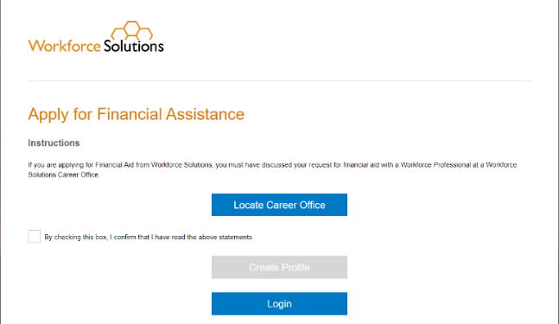
- Customers must check the box agreeing to discuss their request with a workforce professional at a Workforce Solutions office for the “Create Profile” button to activate. Once the statement box is checked, customers must click the Create Profile button.
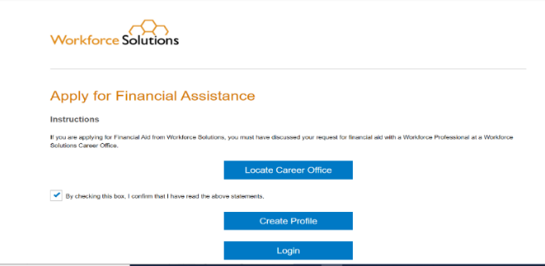

- Create a Profile
The Profile screen displays.
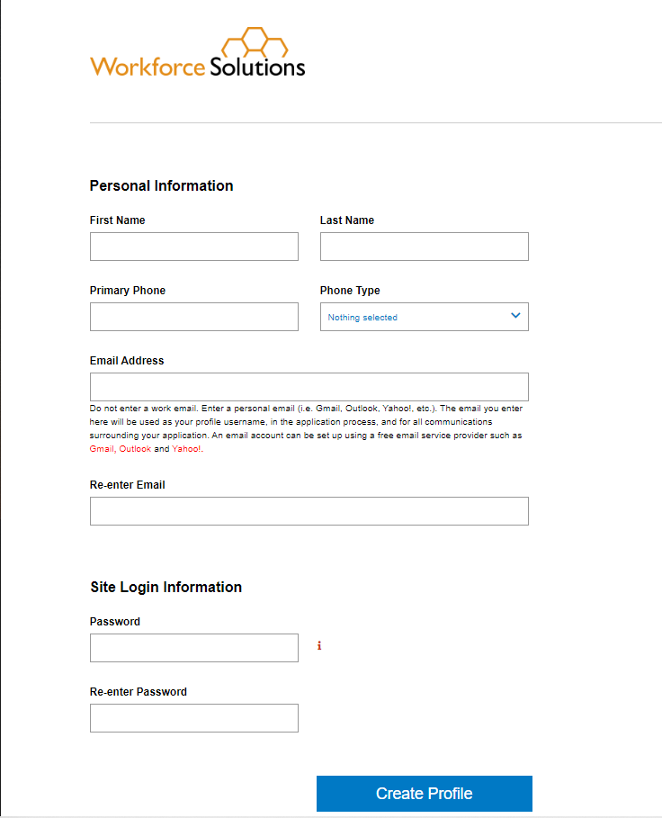
Customers must enter the required contact information:
- Name
- Phone number
- Email address
NOTE: Customers without an email address can create one by clicking on the link to their preferred email provider below the email address field and completing the setup process for the provider.
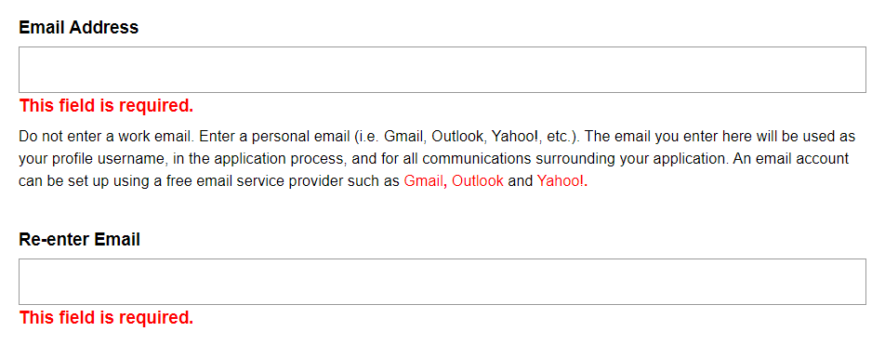
A secure password must contain at least:
- eight (8) characters
- one uppercase letter
- one lowercase letter
- one number
- one special character (! @ # $ % ^ & *)
When all information is entered, customers click the Create Profile button. The Verify Email Address screen displays.

To confirm and verify their email address, customers must:
- Click the Send Verification Email button. A verification email is sent to the email address listed on the customer’s profile.
- Login to their email address.
- Retrieve the verification email from WFSFinancialAid@wrksolutions.com.
Note: If the email is not in the inbox, ask the customer to check their Spam folder.
- Click the VERIFY link in the verification email.

- The Email Verified screen displays.
- Customers click the Continue button. The Welcome/Services page displays.
To continue the application profile, customers:
  - Check the applicable box(es) to identify the services they need
  - Agree to an assessment within 14 days by clicking, I Agree
  - Answer the questions on the Financial Assistance page and click Next.

- Complete the application and upload supporting documents.

The Financial Assistance – Getting Started page displays.
At this point, customers may choose to logout and return to complete the application at a later time.
IMPORTANT NOTE: If an application is not submitted within 14 days, the customer will have to reenter their application information in their profile.
To continue, customers click Application Progress. The Application Progress screen displays seven steps to complete. For each step, customers must answer a series of questions and click Next at the end of each page. Once the customer completes a section, the Complete Section button displays. At this point, customers can click on the Save & Logout button, save what they’ve done, and return to complete the application at a later date.
Note: If a step has been completed, a link to ‘Edit’ the information displays in place of the Start button.
Once all sections have been completed, the customer clicks the Complete Section button to save the information.
NOTE: If the customer is a Veteran, the Veteran Addendum must be completed.
The Family Information screen displays. Customers can choose to logout and return to the application at a later time by clicking the Save & Logout button at the top of the screen.
Family Information
Customers must provide information about their household members and their own and family members’ employment, income, and public assistance.
If a family member requires childcare, the Addendum for Childcare Assistance page displays for customers to enter their selected child care provider information. If they haven’t chosen a provider, they have the option to click Next to continue.
The Addendum for Child Care Assistance (Parent Agreement) displays.
The Parent Agreement is made up of two pages. For each page, customers must read and agree to each statement by clicking the check box next to “I Agree” and clicking the I Accept button at the bottom of each page. The Documentation page displays.
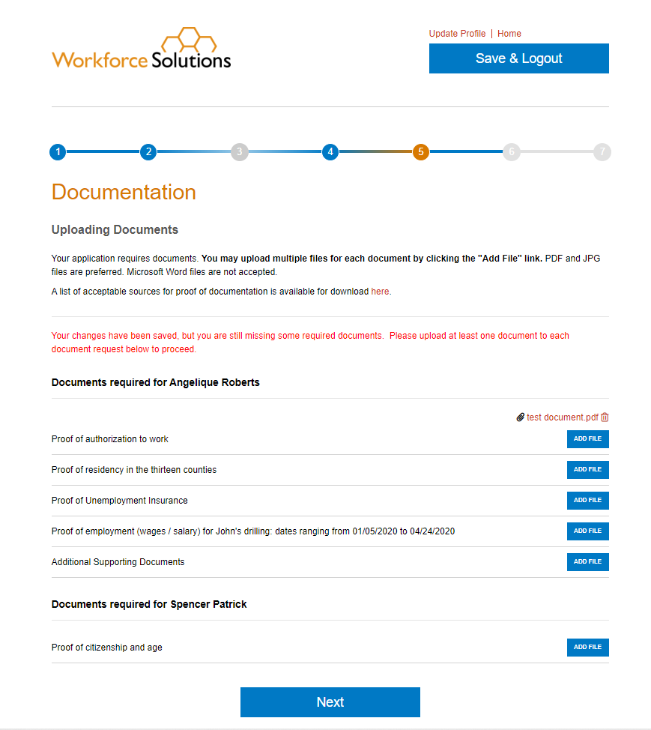
- Documentation
Based on the services requested, customers must upload documentation which supports the information they’ve provided in the application. A list of required documents displays on the page.
Note: Only .pdf and .jpg versions of documents can be uploaded. If customers are unable to upload their documents, ask the customer to email their documents to you or the office’s general email address.
To add a file:
Click Add File next to the document type. The file navigator pop-up window displays, allowing a customer to locate the document on the computer. Customers must select the document by double-clicking on it or clicking the Open button. The document is uploaded and displays to the right of the document type. Customers will need to complete the steps to add files over until they have uploaded all required documents. When all documents are uploaded, the customer clicks Next to continue the application.
NOTE: To continue the application, required documentation must be uploaded. A customer may click the Save & Logout button to stop the application, gather the documents, and return later. To see a list of acceptable documents for child care, click here. To see a list of acceptable documents for scholarship, click here.
The Orientation to Discrimination Complaint Procedures page displays.
- Orientation to Discrimination Complaint Procedures
The Orientation to Discrimination Complaint Procedures form addresses discrimination complaint procedures for the programs and services Workforce Solutions offers, including:
- Workforce Innovation and Opportunity Act (WIOA)
- Temporary Assistance for Needy Families (TANF)/CHOICES
- Supplemental Nutrition Assistance Program Employment & Training (SNAP E&T)
- Child Care Services (CC)
- Trade Adjustment Assistance (TAA) and Trade Readjustment Allowances (TRA)
Customers must click I Accept to acknowledge they have read and agree to the information in the document. The Disclaimers page displays.
- Disclaimer
Customers must read and agree to the disclaimers on the page by clicking the box next to each statement and choosing the date. Statements include:
- I understand that providing false information or failing to disclose information in order to appear eligible for financial aid is considered fraud. A person, who obtains, or attempts to obtain by fraudulent means, services to which the person is not entitled, may be prevented from receiving future financial aid from Workforce Solutions, must pay back financial aid received, and may be prosecuted under applicable state and federal laws.
- I give permission to Workforce Solutions to contact third parties to verify information pertaining to my application for financial aid.
- I certify that my answers are true and complete to the best of my knowledge.
- I read and signed the Orientation to Discrimination Complaint Procedures form.
By selecting the "I Accept" button, customers are signing the Agreement electronically. They agree their electronic signature is the legal equivalent of their manual signature on this Agreement.
Customers must click the I Accept button to continue.
- Submit application for approval.
The Final Review page displays.
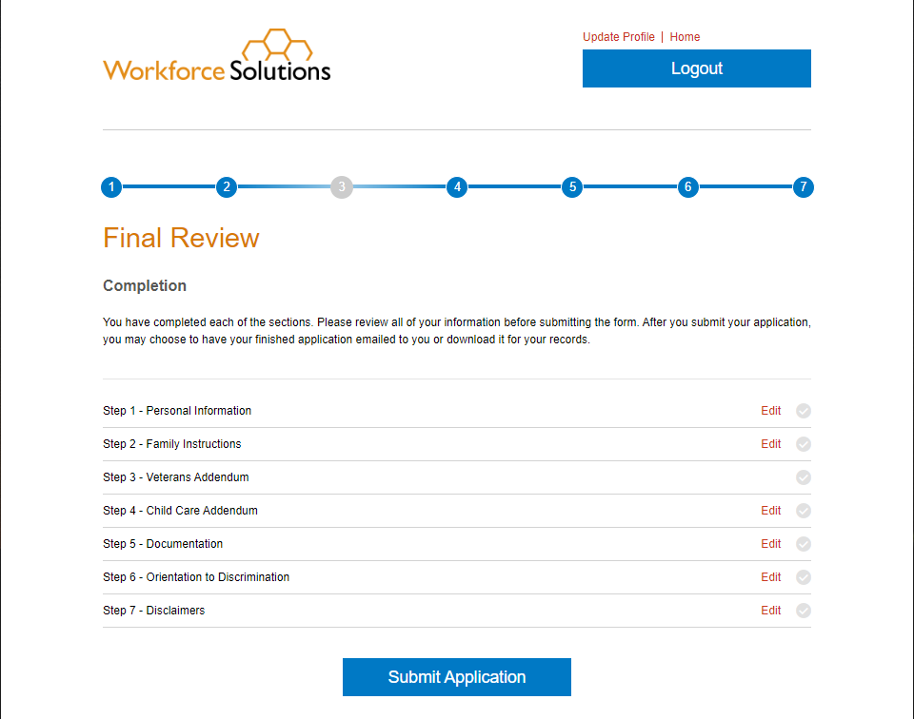
Customers have the option to review all the information entered by clicking the Edit link next to each step. When a customer is satisfied all information is complete, they click the Submit Application button.
The Social Security Number pop-up displays.
Providing a Social Security Number (SSN) is optional. Customers can enter their SSN and click Submit or click on Skip.
The Application Submitted page displays, informing the customer their application has been submitted. Customers may choose to download a copy of the application or have it emailed for their records.
Remember:
- Follow the current financial aid process.
- For customers applying for substantial financial aid, an assessment is required prior to an eligibility determination by the Financial Aid Support Center.
- Use the Validating and Entering Qualifications for Workforce Solutions Financial Aid (VEQ) to help your customer gather the necessary supporting documents prior to completing the online Financial Aid Application.
- This is the new normal.
- Familiarize yourself with the online application. Watch the eLearning - Financial Aid Application: Assisting Customers with the Online Process, available on the LMS.
- Ask questions and notify the contact person at your office or your assigned Subject Matter Expert (SME) if you encounter problems.
- Provide excellent customer service.
- Be patient with customers as they complete the online Financial Aid Application.
- Follow-up with customers once you’ve referred them to apply online to answer any questions.

