New WIT WP Employment and Education Fix Quick Pick
Overview:
The Texas Workforce Commission (TWC) identified an issue with the inability for staff to complete the Wagner Peyser (WP) Program entry on certain participants due to the education and or employment screens being grayed-out in WorkInTexas.com (WIT).

Solution:
A new WIT WP Employment and Education Fix Quick Pick has been created in FACS for office staff to communicate the information needed by the tracking units to update the customer’s information in WIT. Failing to report this information could affect reporting.

Instructions:
Effective immediately, if while working with a customer staff encounter the grayed-out education and employment screen, they should follow the instructions below to submit a FACS issue.
- Quick Pick Name: New WIT WP Employment and Education Fix Quick Pick
- Impacted Group: All Career Offices and Tracking Units
The new WIT WP Employment and Education FACS Issue requires the following information in the Subtype to WIT Education and Employment Options:
- TWIST ID
- Customer First Name
- Customer Last Name
- WIT State ID
- Highest School Grade Completed
- Highest Postsecondary Education
- School Status
- Current Employment Status

Description section:
Use this FACS issue when staff are unable to complete the Wagner Peyser (WP) program entry on a customer’s profile due to the education and/or employment screens being grayed out. Enter the customers state ID and first/last name. Select an option under sub type 1 (WIT Education Options) and/or sub type 2 (WIT Employment Options). The FACS issue is next actioned to the Tracking Unit assigned to the Career Office for assistance.

Sample FACS Issue
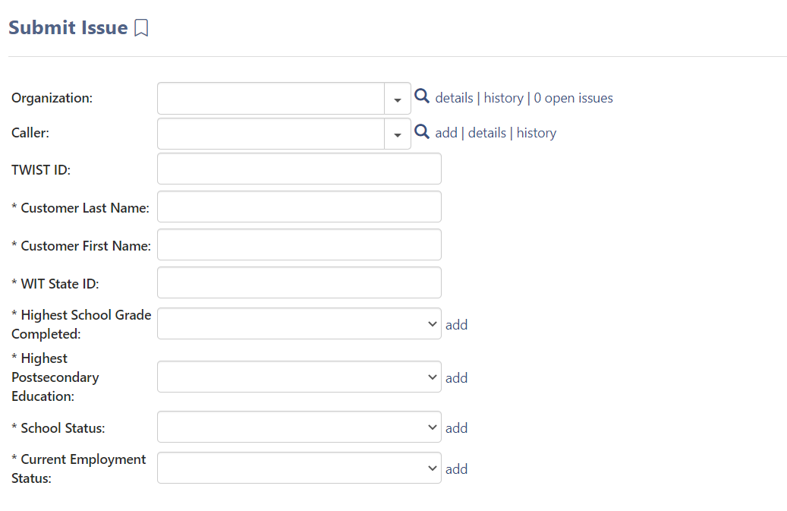
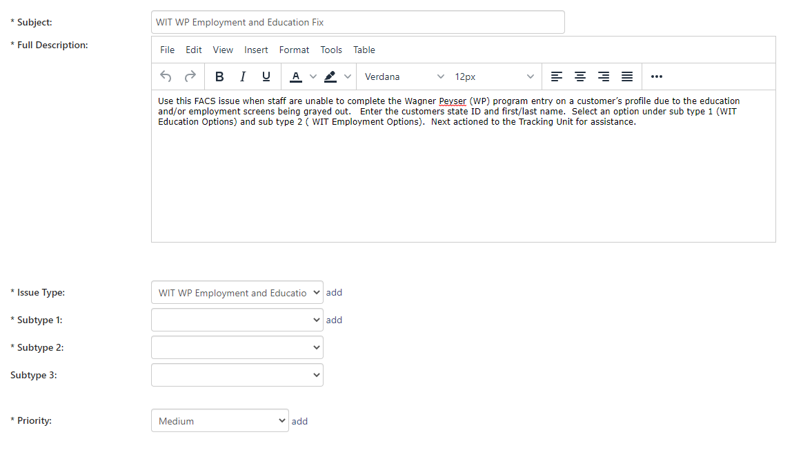
Trackers Responsibility
Trackers will prioritize the WIT WP Employment and Education Fix Quick Pick and must correct the information in WIT within 24 hours of the submission date and time. If the Tracker is unable to resolve the issue, the Tracker should email WorkforceSecurity with the details.

