  
**Trade Adjustment Assistance (TAA) Reversion 2021 Desk Aid**

On July 1, 2021 TAA reverted to the Trade Adjustment Assistance Reauthorization Act (TAARA) of 2015, with some modifications. Absent new legislation, the Reversion 2021 program will remain in effect until June 30, 2022.

All petitions filed with the US Department of Labor (DOL) after July 1, 2021 will be assigned a petition number of 98,000 or above.

**Our Process**

1. Merit staff at the Support Center will receive a list of affected workers from the Trade Services Unit. They will reach out to affected customers via phone and email.  Customers who respond to merit staff will be routed to a Career Advisor in a career office.  Career Advisors will schedule an appointment with the customer via Appointy **as soon as possible**.
2. Career Advisors will conduct an orientation, ensuring they address the following:
   1. The waiver deadline is **10/30/2021**, not 03/05/2022.  There is a counselor note that reflects the 10/30/2021 deadline, but the place where the deadline typically is, shows 03/05/2022.

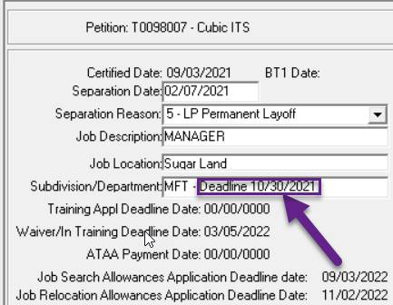

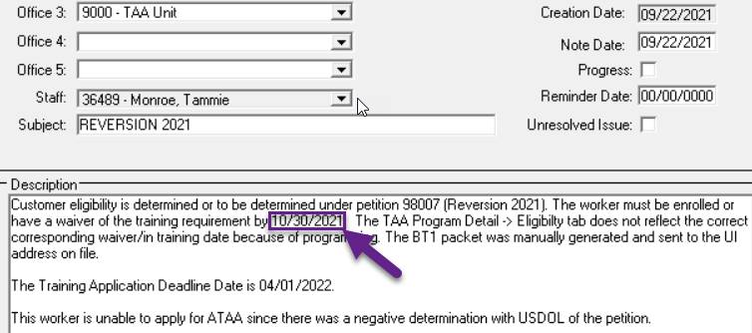

* 1. The TRA application is in the packet mailed to the customer and needs to be completed and scanned into DocuWare as soon as staff meet with the customer.  Merit staff will forward it to Trade Services Unit.
  2. If the customer declines the initial assessment or TRA, staff must explain to the customer and document in TWIST, their declination will impact their eligibility for future TRA payments.
  3. Staff **must** offer co-enrollment into WIOA Dislocated Worker. If the customer declines, they must sign the co-enrollment declination form (<https://www.wrksolutions.com/Documents/Staff/tradeact/TAA-Coenrollment-Declination-Form.docx>) and staff must document the declination in counselor notes.
  4. For Reversion 2021 customers, OJT and Apprenticeships (work-based learning) are the preferred method of training over traditional classroom training.
     1. Staff will need to explore OJT/Apprenticeship programs before traditional classroom training. Staff should:
        1. Keep the occupational goal in mind, and
        2. Consider LMI: what jobs are available and what employers need
     2. Staff can use the following resources to identify available OJT and Apprenticeship programs:
        1. The LMI report sent by ETC lists current OJT and Apprenticeship programs with employers in our region.
        2. DOL website: <https://www.apprenticeship.gov/career-seekers>.
     3. If the customer requests a classroom training, but an OJT/Apprenticeship program is more suitable for the customer,
        1. Staff must:
           1. recommend denial for the customer’s request for classroom training; and
           2. document in a TWIST Counselor Note the reason for denial. Staff must include supporting documentation.
        2. Merit staff will submit the recommendation to Trade Services for final determination.
     4. If the customer requests a classroom training, but an OJT/Apprenticeship program is not available for their occupation, staff should work with the customer to enroll in the classroom training, as appropriate.