**Amazon Purchasing Process**

|  |  |
| --- | --- |
| **Career Office Staff** | * Completes assessment and establishes need * Enters Counselor Notes in TWIST * Shops with customer on Amazon and submits item(s) to Amazon cart > Customer TWIST ID is PO# * Completes order to submit approval request * Submits Financial Aid Assistance Request Form for approval * Creates customer Gazelle account |
|  |  |
| **Career Office Management or Designee** | * Reviews Financial Aid Assistance Request Form * Approves order in Amazon and places order * Ensures Gazelle support account is created * Submits documents to Tracking Unit via DocuWare |
|  |  |
| **Tracking Unit** | * Verifies eligibility * Data enters support service(s)   + TWIST   + Gazelle - creates requisition which is routed to FAPO |
|  |  |
| **FAPO** | * Matches Amazon invoice to requisition request via TWIST ID# * Pays invoice |

*The Amazon purchasing process only changes the method used to provide work support to the customer. The internal process to provide and receive approval for work support remains the same.*

Use the Workforce Solutions’ Amazon business account to purchase items for a customer requesting work support.

## Join the Amazon Business Account

1. Request access from your supervisor. You will be designated as either a requisitioner (able to purchase items) or an approver (able to approve purchases made by staff).
2. When you receive the invitation to join in your email, click the **‘Join Amazon Business’** button to begin the set-up process.

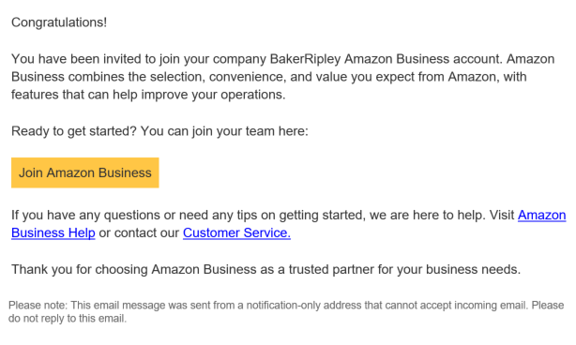

1. Your UserID is your email address. Create your password.

You can begin purchasing as soon as your account is set up.

## Purchase items for a customer

When a customer requests work support, begin the process by having a conversation to confirm what the customer needs, what we can provide, and the customer’s eligibility for short-term or substantial support. Complete the documents required for the type of funding requested, including the *Work Application Addendum*, the *Financial Aid Request* *Form*, with **‘Online Purchase’** checked and the Amount field completed, have the customer sign the *Orientation to Discrimination Complaint Form (OTC),*complete the *I-9 checklist* based on what the customer provides to prove they are eligible to work in the U.S., and document your assessment in TWIST Counselor Notes.

Note: Eligibility for substantial support is determined by the Financial Aid Support Center (FASC) from a completed Financial Aid Application.

Next, select the times for purchase through Amazon Business.

1. Search for the product(s) your customer needs by using keywords in the search bar, selecting from one of your **Lists**, or selecting **‘Buy Again’** on the top menu bar to choose from products you have previously purchased.

Note: Some categories are restricted, - e.g., alcohol and computers.

Use filters and lists to refine your search options.

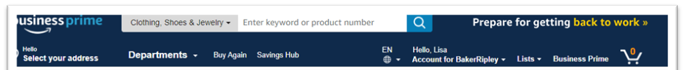

1. Select items to buy by clicking **‘Add to Cart.’**

Important Note: Select only items that have the Prime icon which indicates free shipping and returns.



1. Continue shopping for all items the customer needs.

Note: You can also create a list to save items to buy later. See page ten (10).

**To check out:**

1. Click on the cart icon on the top navigation bar. Your cart displays the list of items to purchase. Make changes or adjustments as needed.
2. Click ‘**Proceed to checkout’** to continue. You may be prompted to sign in again to verify your account. The **‘Business order information’** screen displays.

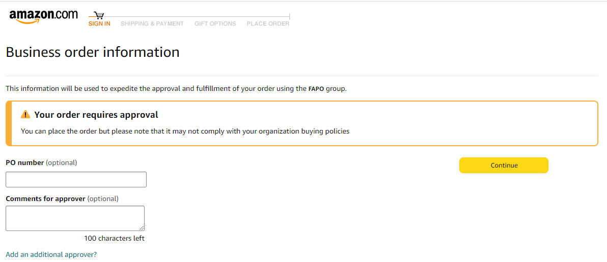

1. Enter the customer’s TWIST ID# in the PO number field.

**Important Note:** This field is marked optional, but this is a **required** field for Workforce Solutions.

1. Enter any comments to help the person approving the order.
2. Click **‘Continue.’** The ‘**Shipping & Payment screen’** displays.

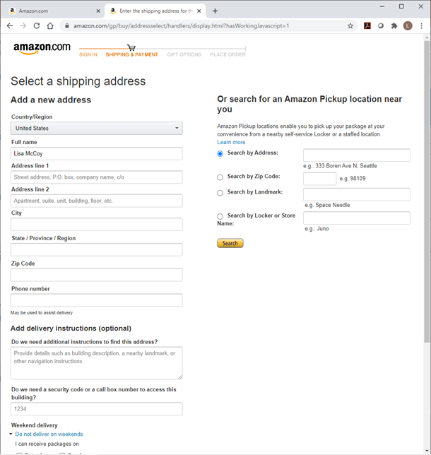

1. Click **‘Add Address.’**
2. Choose the shipping option. Enter the customer’s address, or select an Amazon Pickup location near the customer.

If you choose to ship to the customer’s address, be sure to include any special delivery instructions such as building codes or special directions to that address.

If you choose an Amazon Pick up location:

* Discuss with the customer the best location for pickup.
* Once the order is complete, you must retrieve a **‘Locker Code’** from **Your Orders.**

**Share with the Customer:**

* The Locker Code so they can access the locker to pick up the order.
* No identification is needed to pick up the order.
* Individuals working where the Amazon lockers are located have no information about the orders or the lockers.
* They have three (3) calendar days to retrieve the order or it is automatically returned.

1. Click **‘Continue.’** The **‘Select a payment method’** screen displays. The FAPO line of credit **‘Pay by Invoice’** option is automatically selected.
2. Click **‘Continue.’** The **‘Review your order’** screen displays. Review all information with the customer one more time to ensure it is correct.
3. Click the **‘Place your order’** button to complete the order. The **‘Business order information’** screen displays.

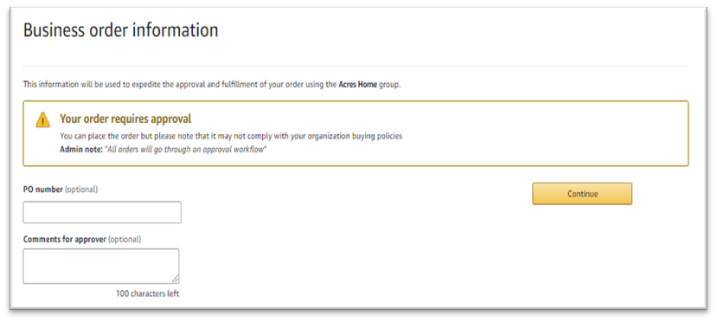

1. Enter the customer’s TWIST ID# in the PO number field.
2. Enter comments to the approver as needed.
3. You will receive an email notifying you when the order is approved.

Note: When you click **‘Place your order,’** an email alert is sent to the individual designated to approve your orders. At the same time you place the order, email all eligibility documents, see page three (3), to the person assigned to approve your orders. If you have questions about the process or who your assigned approver is, speak with your supervisor or manager.

An order can be canceled any time before the shipping process begins - usually, the same day the order is placed.

1. Complete data entry. This may include:
   1. TWIST Counselor Note including:
      1. an itemized description of item(s) purchased and their cost
      2. paperwork submitted and to whom it was sent
      3. any special notes
   2. Support Service line in TWIST
   3. Save all documents to DocuWare with the label **‘Support Service’** and the customer’s identifying information, including their TWIST ID#.
      1. Work Application Addendum
      2. I-9 documentation
      3. I-9 checklist
      4. Financial Aid Request Form
      5. Orientation to Complaint Form
      6. Amazon receipt

## Your Orders

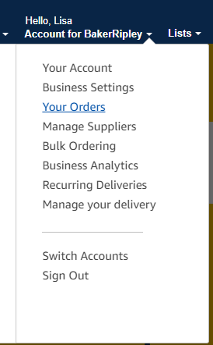The **‘Your Orders’** page provides additional detail regarding the status of all the orders you have placed.

To access **‘Your Orders’**:

1. Click the arrow next to **‘Account for BakerRipley.**’
2. From the dropdown menu, select ‘**Your Orders.’** The **‘Your Orders’** screen displays.

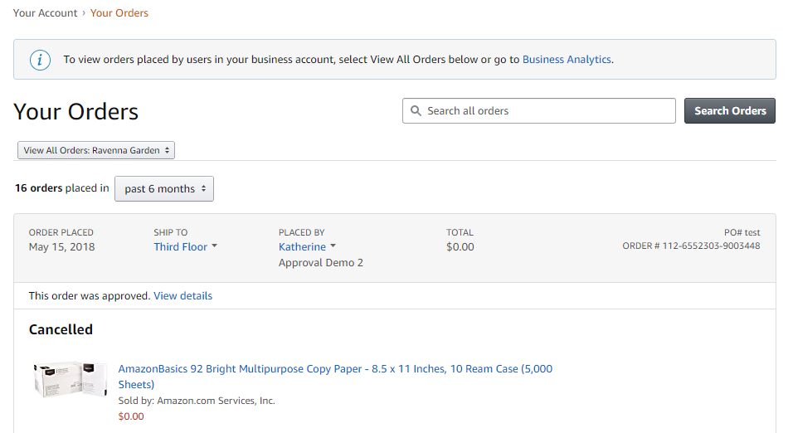

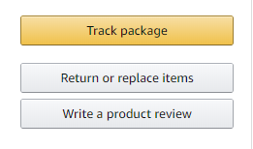

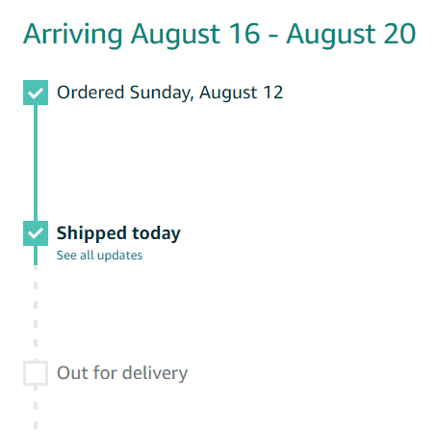

Returns

Returns and exchanges are free through Amazon. If **you** placed the order, **you** must be the one to initiate the return process on Amazon.com. Returns can be completed either by packing and shipping it yourself, by dropping it at an Amazon designated location where they will pack and ship the item, or allowing the customer to do either. If you have questions, speak with your supervisor or manager.

To initiate a return:

1. From the **‘Your Orders’** page, select the item you wish to return.
2. Click the **‘Return or replace items’** button.

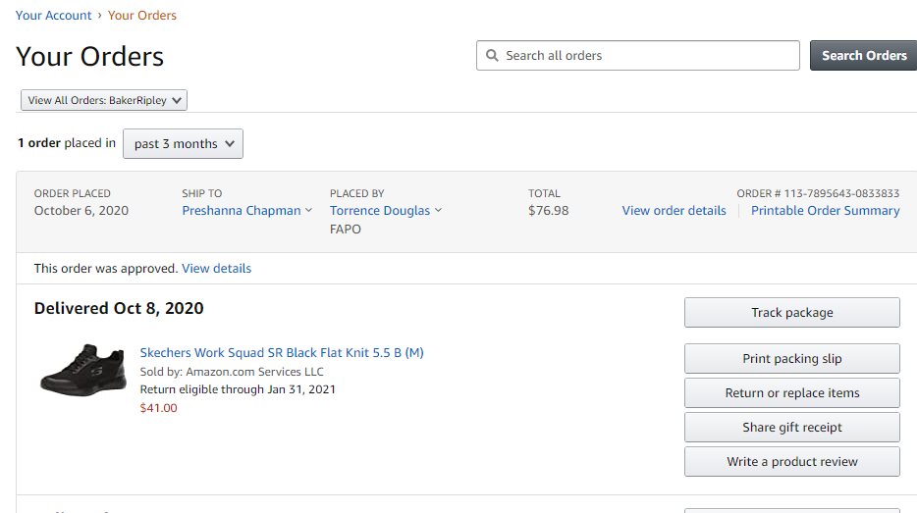

1. 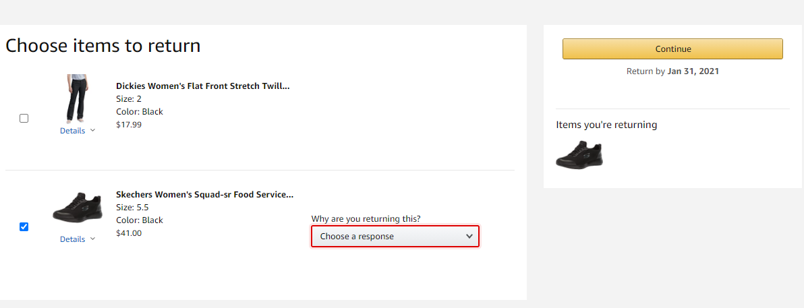Choose the items to return by clicking the radio button to the left of the item.
2. Select the reason for the return from the dropdown list.
3. Click **‘Continue.’**
4. Select the option to return or exchange.
5. Select the method of refund, or replacement.
6. Click **‘Continue’** or **‘Submit return request.’** Note: **‘Submit return request’** allows Amazon sellers to review the return before authorizing a refund or replacement.
7. Choose the method you wish to use to return the item(s).

If you chose to ship it, you will receive a shipping label and instructions via email.

* Box the item(s),

**Note**: Each return label is assigned to a specific return order. To ensure refunds are processed correctly, include items from each order in different boxes with the appropriate label attached.

* Attach the label securely to the top, and
* Take it to the designated shipping location, USPS or UPS store.

If you chose to drop it at a designated Amazon location, you will receive an email with a QR code you must present to the location for the return.

* Take the unboxed item to the location,
* Present the QR code (print or electronically), and
* You will receive an email telling you the item is accepted for return, and when the return is processed.

Track the status of a return in **Your Orders** by selecting **View Return/Refund Status** in the order.

1. Document the return in TWIST Counselor Notes stating the reason for the return.
2. Store emails received and/or a copy of the return label in DocuWare with the label **‘Support Service Receipt.’**

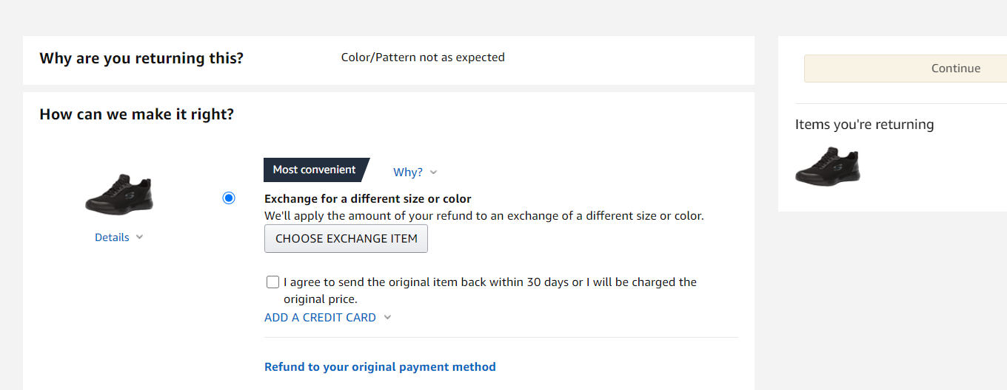

## Create and Use Lists

**Use Lists to:**

* keep track of things you purchase often and reorder,
* create a shopping list for a customer, so you can purchase later,
* share lists and items with others within the Workforce Solutions group.

A list of frequently requested items which meet the category limits has been shared with career offices. This is not meant to restrict purchases to only items on the list, but to assist you in moving through the process quickly.

**To create a List:**

1. Select the **‘Lists’** option from the top menu bar.
2. Click the **‘Create a List’** button. The **List type** pop-up displays.

* 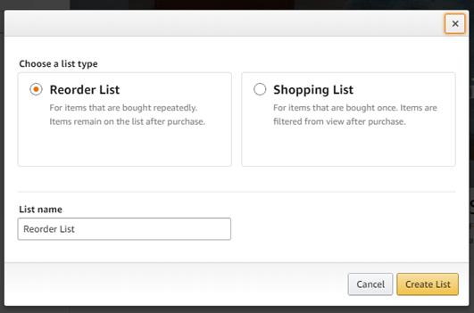Select **‘Reorder List’** if you want items you buy often to remain on the list after they are ordered.
* Select **‘Shopping List’** if you want items to be removed from the list once they are ordered.

1. 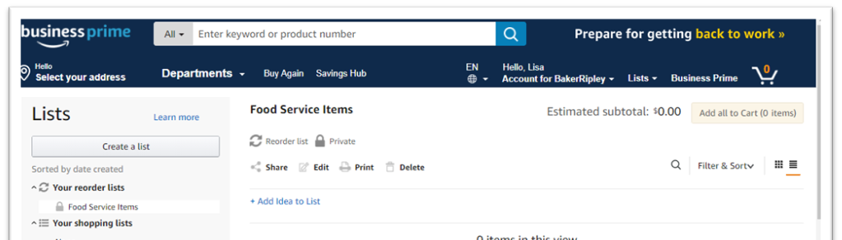Give your list a name. Click the **‘Create List’** button. Your list displays.
2. Begin adding items to your lists as you browse Amazon.

To share your list with coworkers,

1. From the List screen, click **‘Manage coworkers’** to select recipients.
2. Enter the names of the people to receive the link.
3. Click **‘Save.’** The names of the people with whom you’ve shared the list display.

When all the items your customer needs are in the cart, continue to check out.

**Approve the order –** Managers or designee

When staff click **‘Place your order,’** an email alert is sent to the individual, Career Office Manager or designee, designated to approve Amazon orders for the office. At the same time the order is placed, staff should send the ***Financial Aid Request*** form with the supporting documentation to the person assigned to approve orders.

After reviewing the Financial Aid Request form, approve or deny the Amazon order.

1. From the email received, click the **‘Approve or reject this order’** button. The order displays in Amazon.

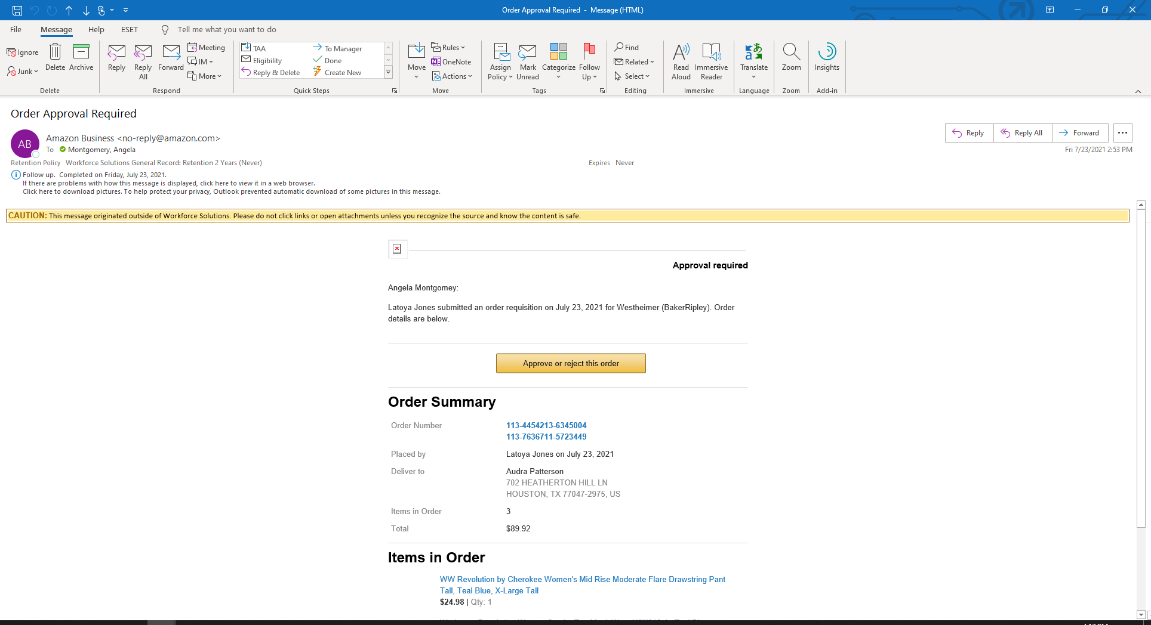

1. Review the order and click the appropriate button to **‘Approve’ or ‘Deny’** the order. If you select:

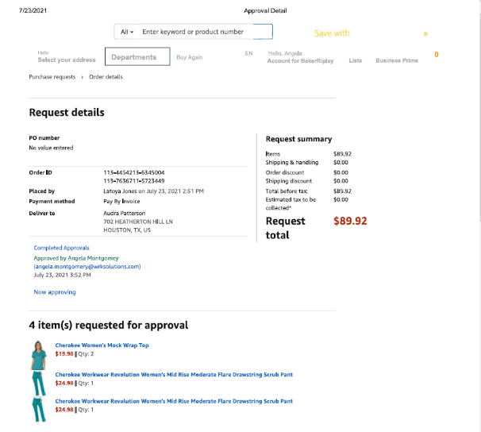

**Approve** - the receipt displays and an email is sent to staff.

**Deny** - staff receives an email regarding the denial.

**Note:** You cannot approve or deny individual items on the order.

The staff who placed the order will receive an email notifying them of the approval or denial.

1. Save the receipt along with the Financial Aid Request form to DocuWare with the label, *Support Service*. Include the customer’s contact information and their TWIST ID#.

Staff can review the status of their orders anytime. Refer to page six (6), **‘Your Orders.’**